**Micro Version of Facebook**

Designer: Zehui Zhan

Date: May 14, 2019

Institution: San Jose State University

Adviser: Professor Wu

Course: Data Structures and Algorithms, CS146, Spring 2019



***Introduction:***

Facebook is an online social media and social networking service company based in Menlo Park, California. It was founded by Mark Zuckerberg with Harvard students and roommates Eduardo Saverin, Andrew McCollum, Dustin Moskovitz and Chris Hughes. It is a popular free social networking website that allows registered users to create profiles, upload photos and video, send messages and keep in touch with friends, family and colleagues.

In this programming assignment, I trying to make a micro version of Facebook, which has the following method: allow the user to check his friends list; allow the user to add friend; allow the user to delete friend; allow the user to search other one’s friend list; allow the user to check two people is friend or not. It also provides the GUI for the users to choose the options. The major function for this project is the Hash Table, which has 15 slots. Since we have

50 distinct users and it causes the collision. There are two way for this programming assignment to solve it, one is Division Method and the other is Multiplication Method. What’s more, I also create my own linked list class to fit the requirement and design the window using the window builder. In the end, using 50 distinct popular names to rest my program. This program only use for the user “James”. The tester “James” could add, delete, search and check friend randomly to check this each function is word or not.

***Table of Contents***

Introduction……………………………………………………………...………………………...1

Table of Contents………………………………………………………………………………….2

Design and Implementation………………………………………………………………….…3-6

A list of classes/subroutines/function calls…………………………………………….…...…….7

Self-testing screen shots……………………………………………………………………...8~12

The procedure (step by step) ……………………………………………………………………13

Problems encountered………………………………………………...……...……………........14

Lessons Learned………………………………………………………………………….………15

***Design and Implementation***

* Class nameNode:

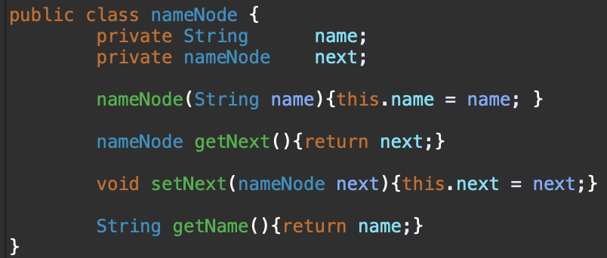The sup class of the class friend list. Help the major class to get the next node and set the next node and get the name of the node (learned from CS46B)

* Class Person

Define a “Person” class which has one field for the name and another field for the linked list of friends. (assume that no two people have the same name.)

* Class friendList



Add a friend to the friend list by the given name. If the linked list is empty, just add it to the head. If the linked list is not, find the last node and add it after the last node.



Delete a friend in the friend list by the given name. if it on the head, just let the head point to the next. If it not, find the node before it and point it to the next.



Check the given name is exited in the linked list or not. Checking every node in the linked list. If find it, just return true. if not, return false

* 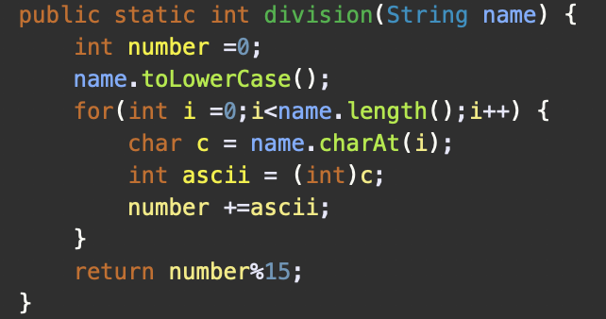Class facebook

Using the division method to solve the collision. Using the ascii to convert the name to the number and mod by the size of the table (15). The result is the slot.

Using the multiplication method to solve the collision. Using the ascii to convert the name to the number. Then the number * A and get the decimal of it by dividing 1. Finally take the floor and which is the slot.

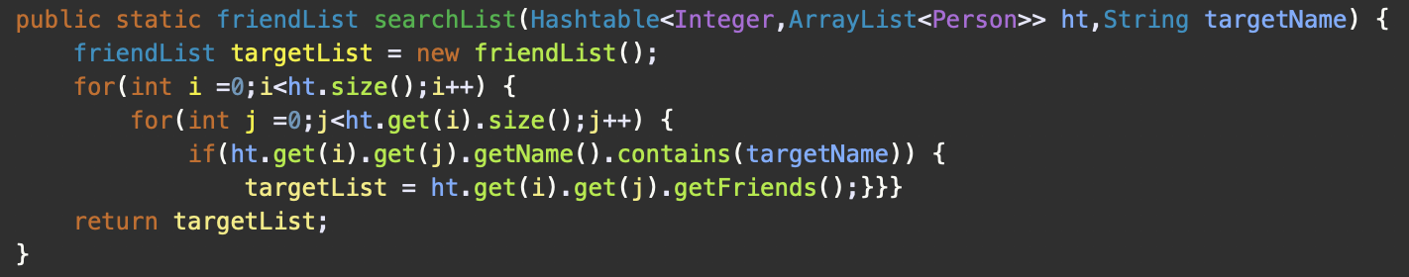

Searching the name in the hash table and return the friends list. Checking every slot and every element in the ArrayList. If the name of the Person in the Array List is equals with the target name, then calling the getFriends() method to return the friend list.

The real add friend method. Adding each person to each person’s linked list.

The real delete friend method. deleting each person in each person’s linked list.

The real search friend method. Searching someone friends list by calling seachList() method.

The real check friend method. Checking two guys is friend or not by calling checkFriend().

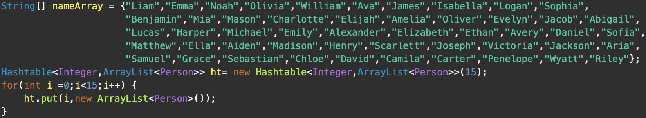Print out the whole hash table in format.

Put 50 name into the String array. Create a hashtable with the key for Integer and the Key for the ArrayList<Person>. Adding the empty ArrayList<Person> to each slot first.

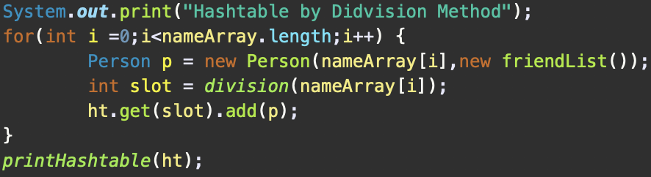Insert 50 names into the hash table by using the division method to solve the collision. Print it.

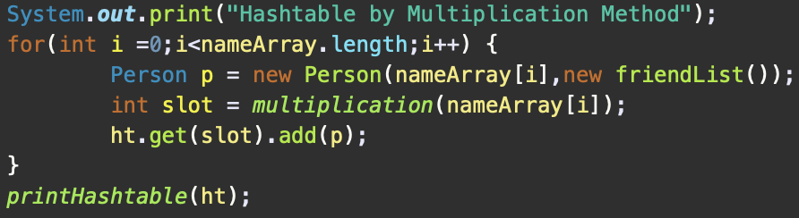Insert 50 names into the hash table by using the multiplication method to solve the collision. Print it

***A list of classes/subroutines/function calls***

* facebook.java

The build of the hash table with some method.

* nameNode.java

The sup class of the class friendList.java

* friendList.java

Define the friend list of the person with some method

* Person.java

Define the Person with his/her name and his/her friend list

* loginSystem.java

The build of the interface of login system

* home.java

The build of the interface of home

***Self-testing screen shots***

* Hash Table
  + 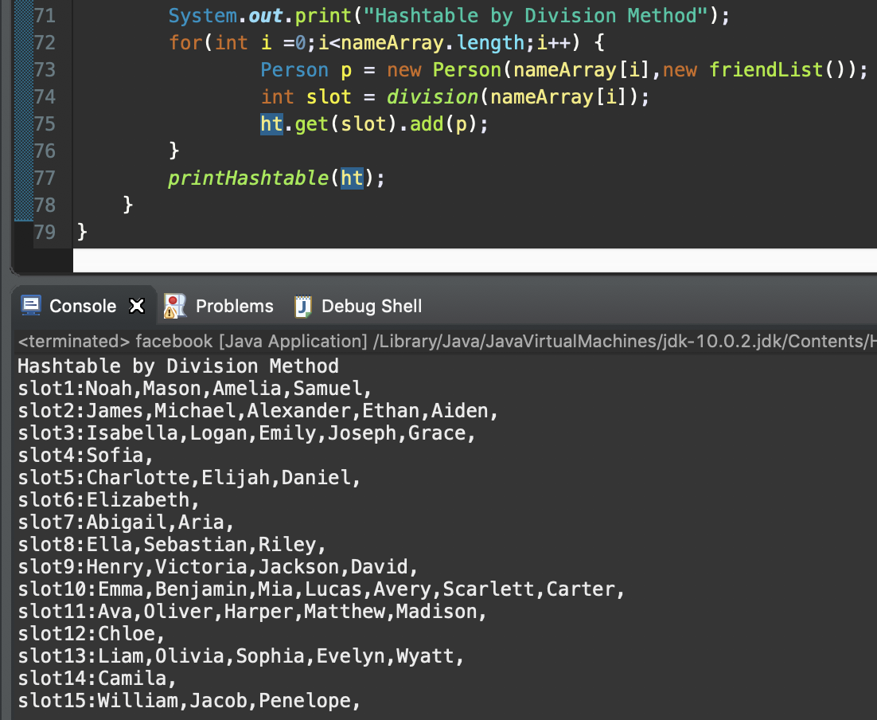Result for the Division Method
  + 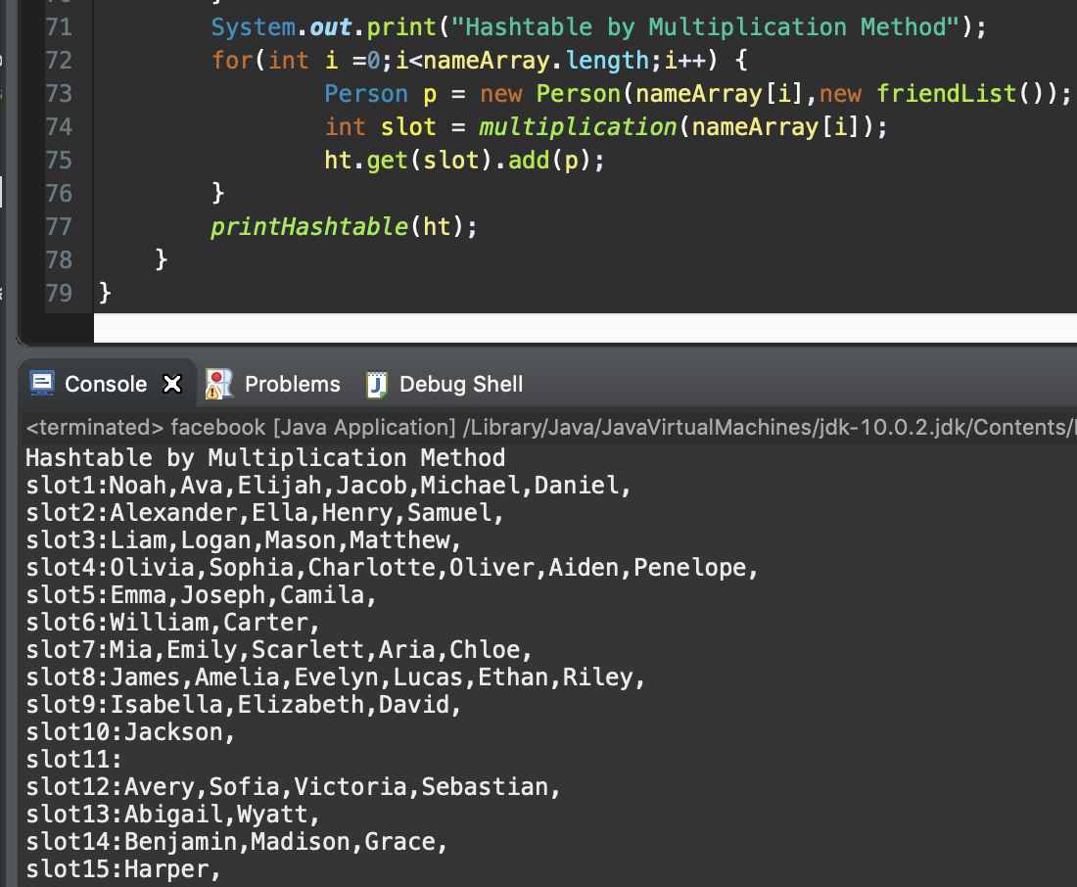Result for the Multiplication Method
* 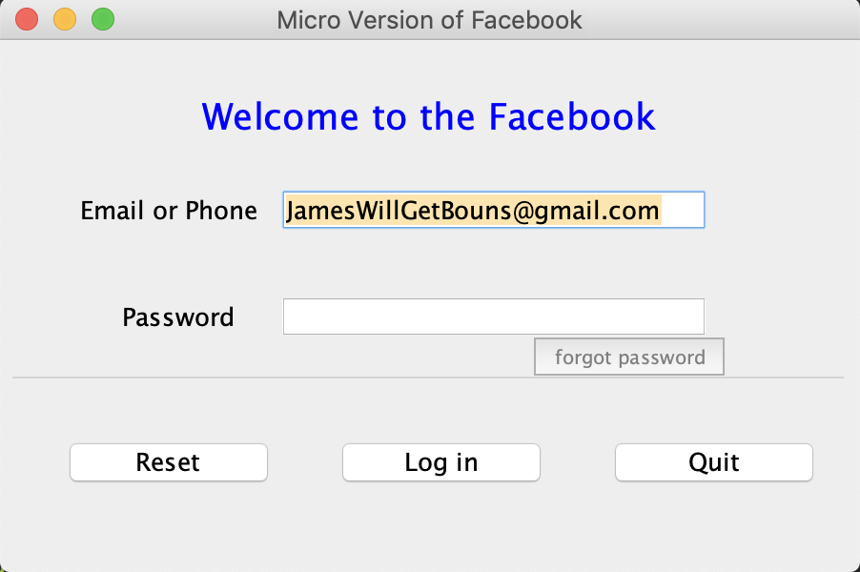Log in System

Forgot password bottom: Reset bottom:

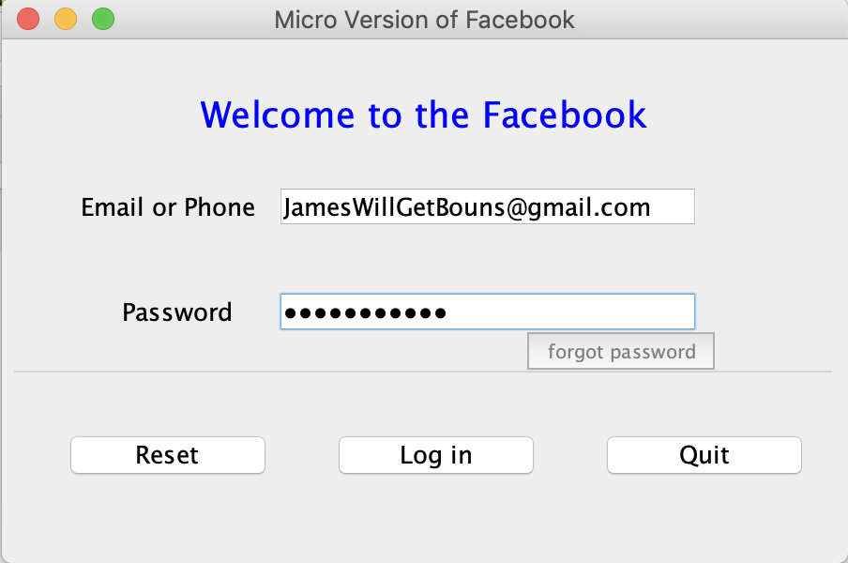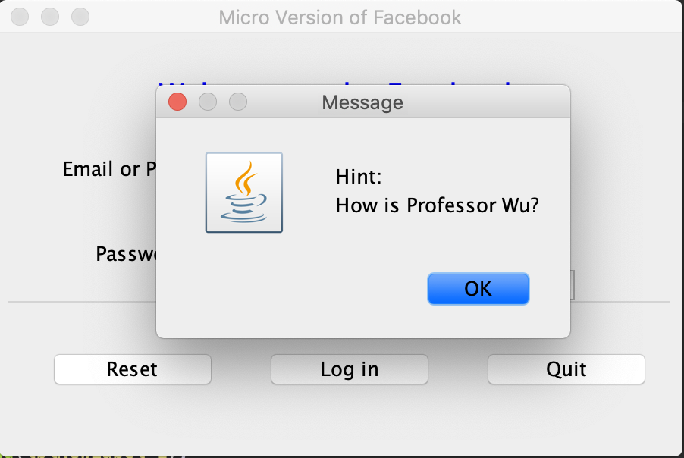

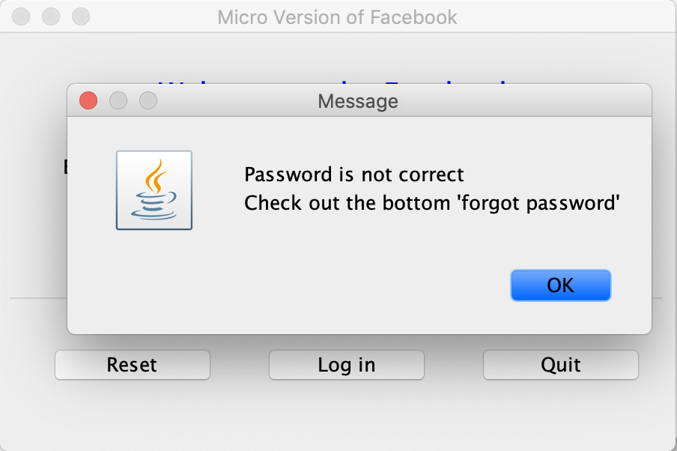If password is not correct: If password is correct:

* Home



when you don’t have friend and click the ‘your friend list’ bottom:

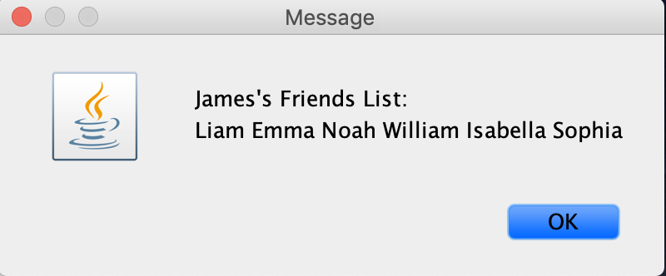When you already have some friends in your list:

* + Add Friend Bottom

When trying to add friend (not exited or “James”)

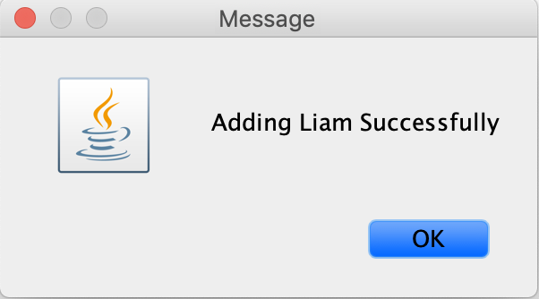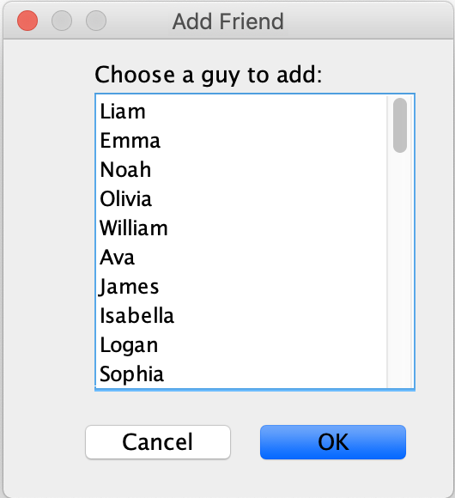

When trying to add friend (exited)

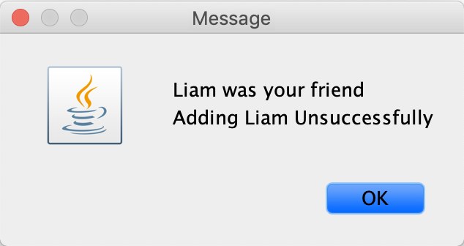

When trying to add friend (“James”)

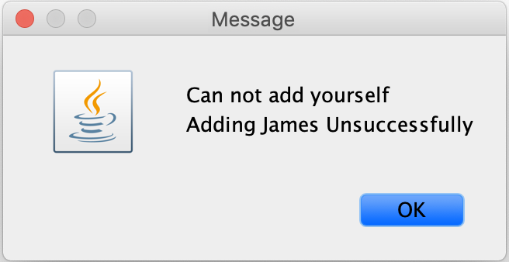

* + Deleting Friend Bottom

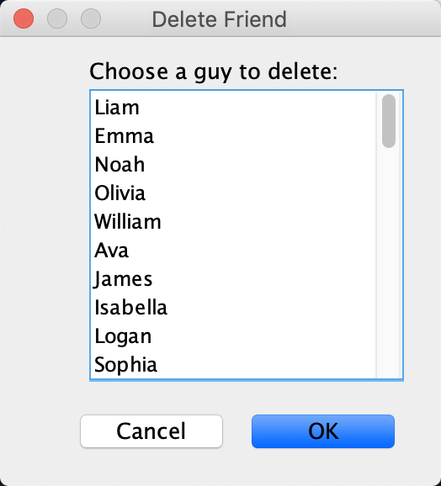 When trying to delete friend (not exited or“James”)

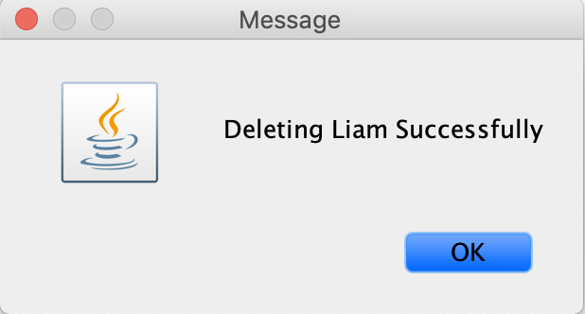

When trying to delete friend (exited)

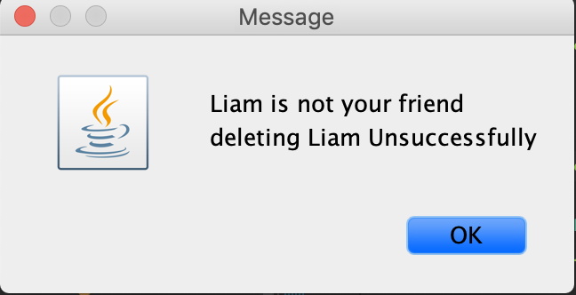

When trying to delete friend (“James”)

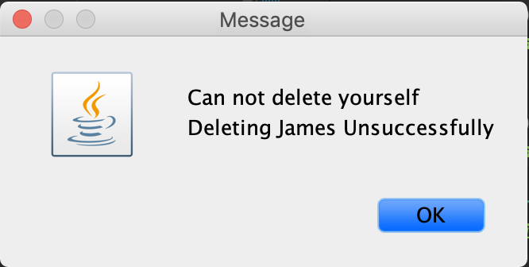

* + Search Friend Bottom



When he/she had added “James”:

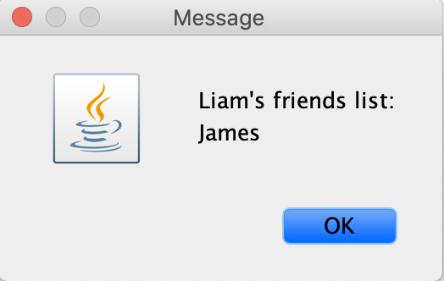

When he/she had not added any one:

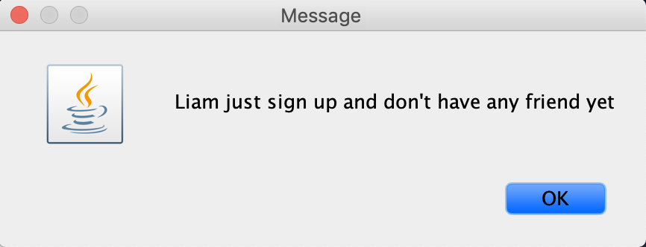

* + Check Friend Bottom:

******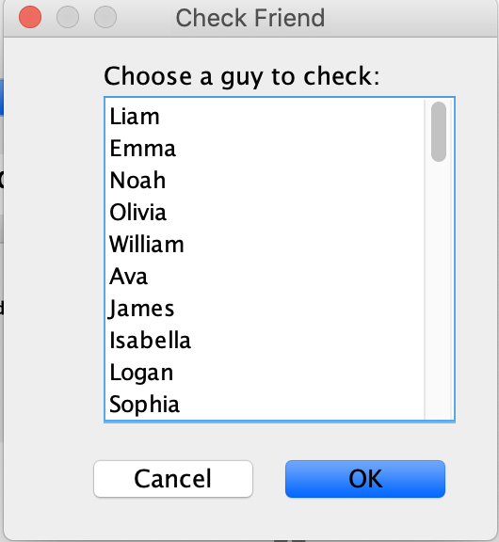

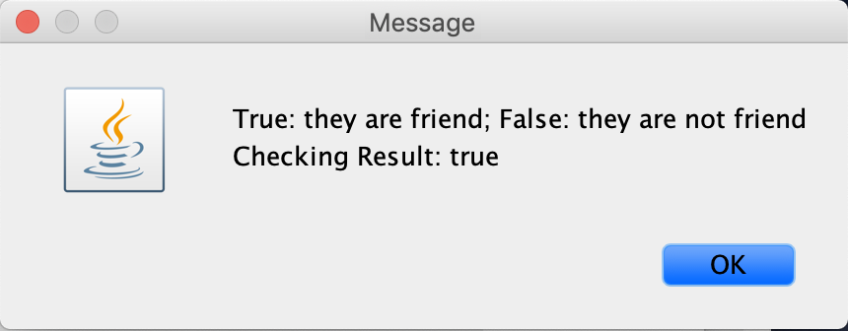If they are the friend (had make friends with “James”):

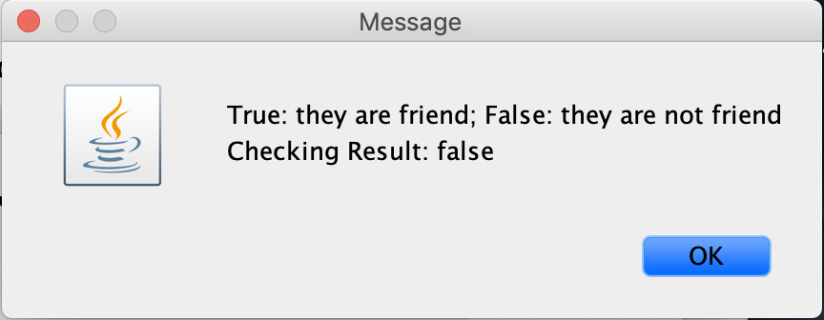If they are not the friend (had not make friends with “James”):

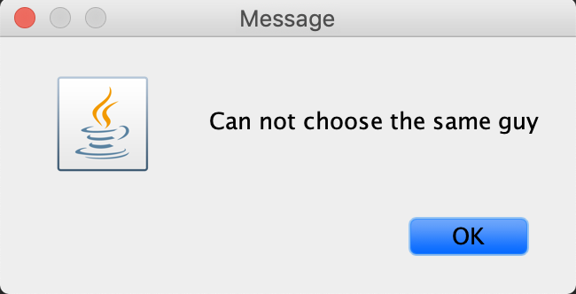If you choose the same guy:

***The procedure (step by step)***

* unzip the file in a normal way
* open the application Eclipse or any Java application
* import the six classes in the file to Eclipse
* go to the loginSystem class and click the running button on the top (green arrow)
* (showing the interface of log in system)
* type in the password: handsome
* (showing the interface of the home)
* try each bottom you like

***Problems encountered***

* How to build a hash table

This problem takes me a whole day to solve it. I know what the hash table look like but really don’t know how to build it in java. Actually, I don’t know what we should use the hash table and how to use the hash table at the beginning. After I think about this part for a day, I figured out why the hash table is convenient and how to build it. Set the key of the hash table to integer, which is the slot of the table. Set the value of the hash table to ArrayList<Person> and the Person class with name and the friend list.

* How to create an interface

When I was searching this question in the google, I got the idea about the Jframe. But when I used the Jframe in practice, it was so complicated to set up the position and the other thing. I searched google again and found this video: <https://www.youtube.com/watch?v=-hpX9oEvoXc>. It taught me how to build a window by the windowBuilder which found in the Eclipse.

* How to inherit a various from the other class

This question is very easy for a student from the CS 46B actually but seem like I already forgot how to solve it. I was trying to inherit the Username from the class loginSystem to the class home, but I was failed to complete it. That’s issue caused a lot of problem and make this project become the one I am not expected.

***Lessons Learned***

Again again again, I have to say thank you so much to professor Wu again. He taught us a lot about the hash table and the hash function. Although I got confused sometime, he is really a great professor and it was my problem not him. This is the first time I create and deal with such a lot of class and function. I am so proud for myself to make it! I got a brunch of benefit from this programming assignment. I learned how to create the hash table in java and how to use it. I never build the window before and don’t know what is JFrame and the “J” something. In this project, I know how to build the window I expected in an efficient way by using the windowBuilder in the Ellipse and know how to downlow a tool in the Ellipse. What’s more, I was trying to figure out everything case when the user using my application like adding the friend already exited in the friend list. But I have thought about the best way to solve this problem, but it was failed since my java skill is not strong enough. This assignment is significantly reinforcing my java skill and make me confident about it. On the other hand, I also learned how the social media like the Facebook work specifically, I could build my own social media application in the future I believe. I really enjoy this programming assignment and looking forward the next one.